Report on task 2

Name: Abdireshov Zhandos

Group: BDA-2004

e-mail: 201045@astanait.edu.kz

Step 1

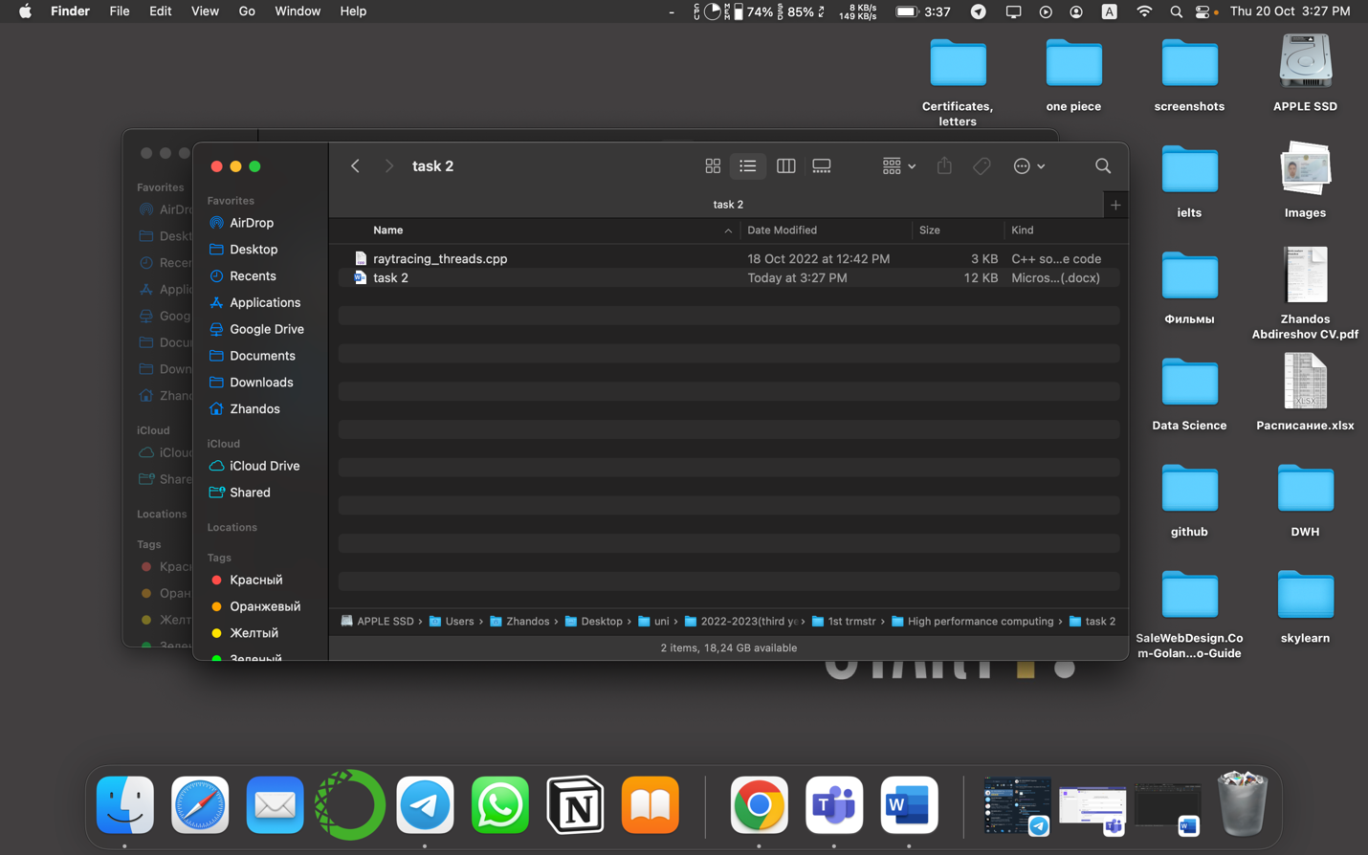

Step 2

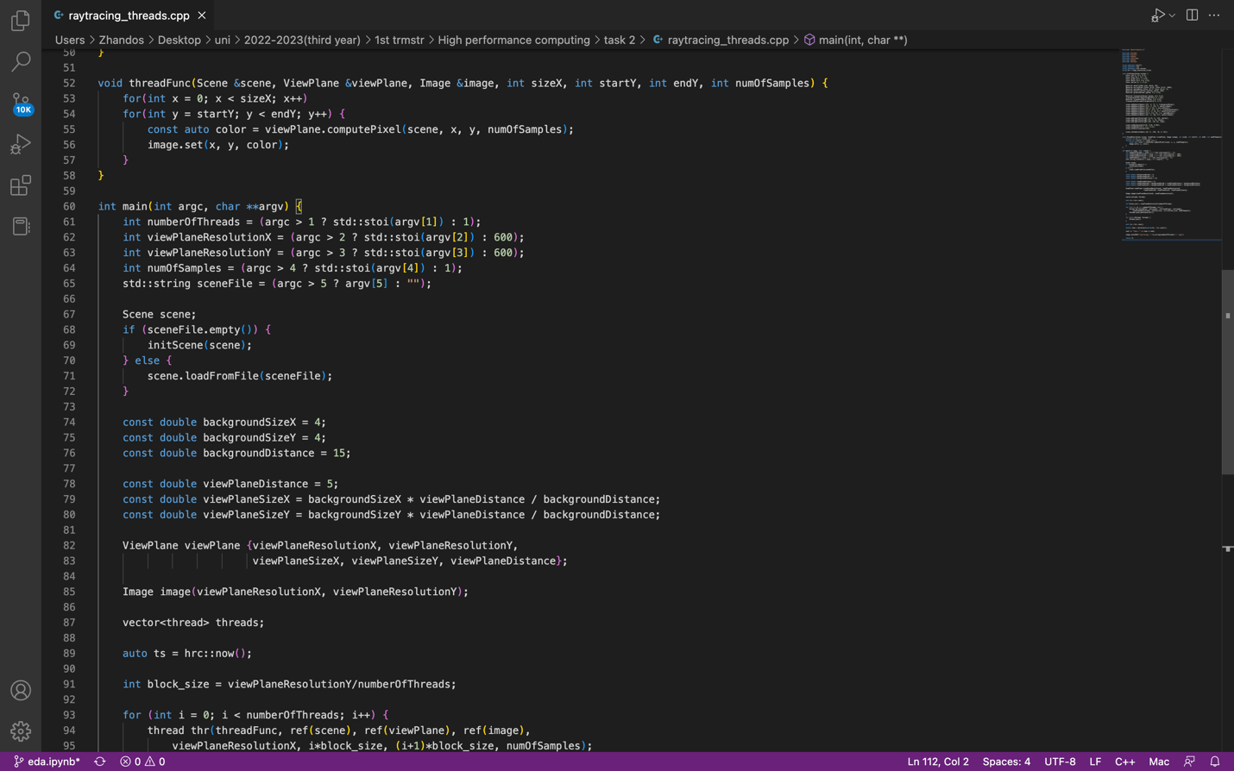

Step 3

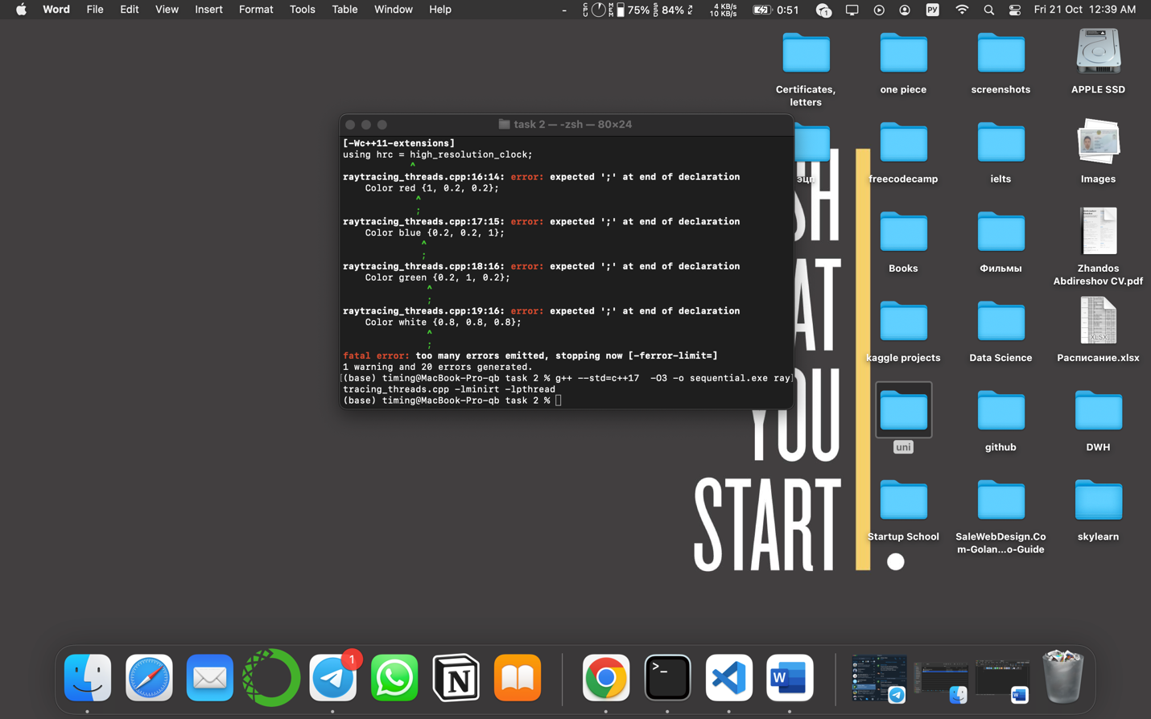

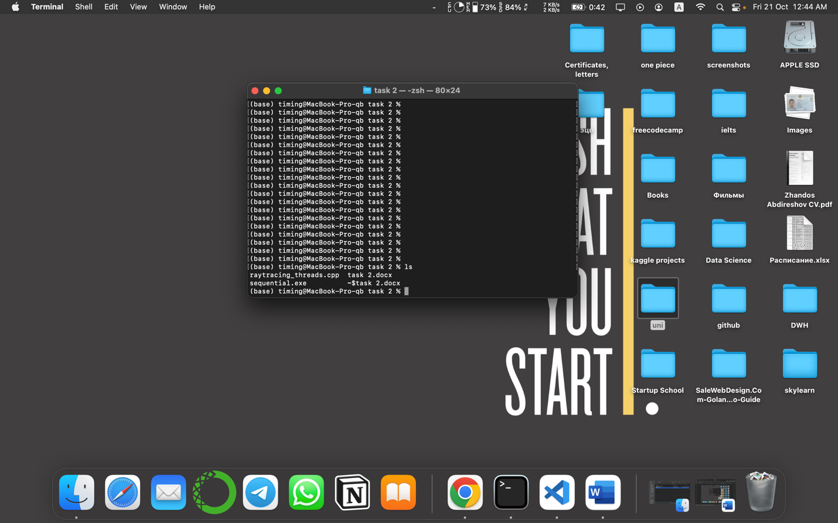

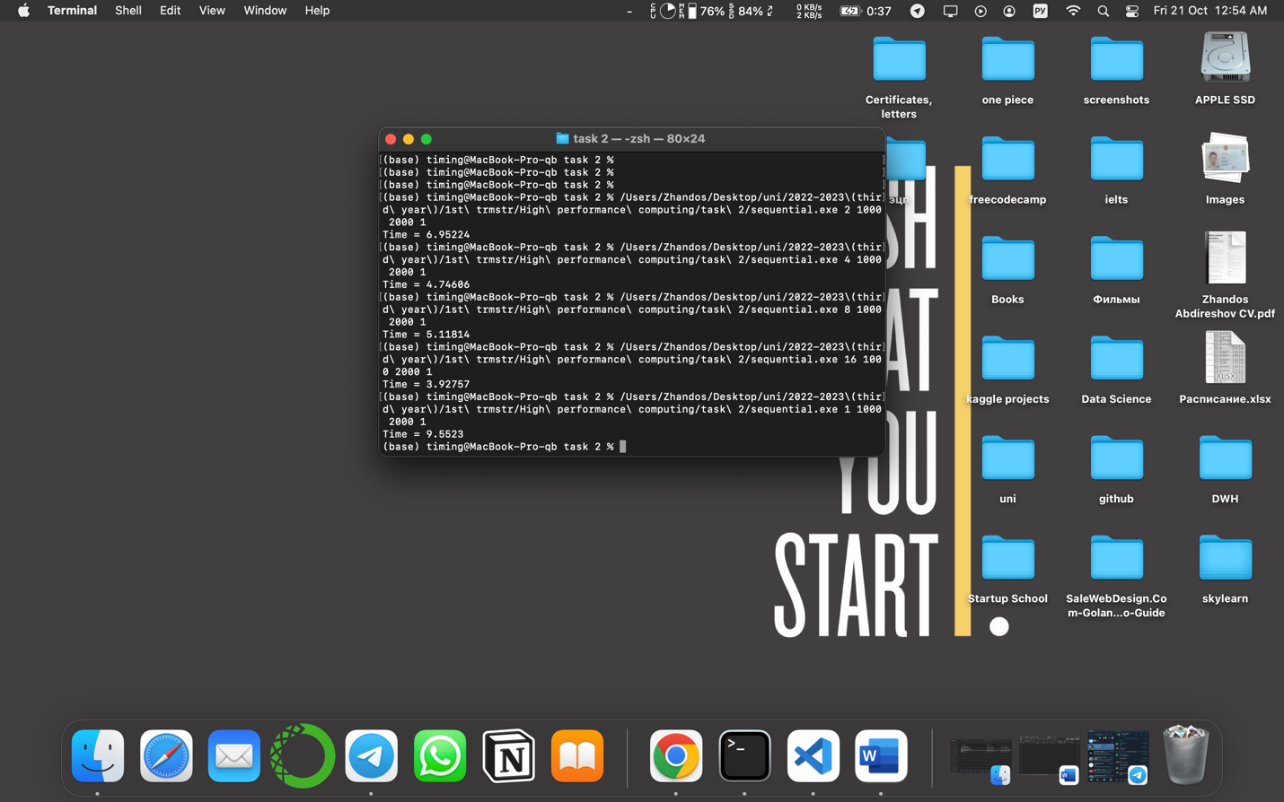

Table

|  |  |  |
| --- | --- | --- |
| Number of threads | Speedup | Efficiency |
| 1 | 1 | 1 |
| 2 | 1,374 | 0,687 |
| 4 | 2,013 | 0,503 |
| 8 | 1,866 | 0,233 |
| 16 | 2,432 | 0,152 |